

**Lab Manual- Create Own Helm Chart**

**Prepared for**:

**Date:** 18th Dec 2023

**Prepared by:**

Document Name: Lab Manual **Document Number** AZLabn916

**Contributor:**

Contents

1. Objective 3

2. Create Helm Chart From Scratch 4

3. Create Template in Helm Chart 6

4. Text Processor in Template in Helm Chart 11

# Objective

Helm charts are structured like this:

mychart/

Chart.yaml

values.yaml

charts/

templates/

...

The **templates/** directory is for template files. When Tiller evaluates a chart, it will send all of the files in the **templates/** directory through the template rendering engine. Tiller then collects the results of those templates and sends them on to Kubernetes.

The **values.yaml** file is also important to templates. This file contains the *default values* for a chart. These values may be overridden by users during helm install or helm upgrade.

The **Chart.yaml** file contains a description of the chart. You can access it from within a template. The charts/ directory *may* contain other charts (which we call *subcharts*). Later in this guide we will see how those work when it comes to template rendering.

**But another step you can take as you can convert that chart into standard Kubernetes YAML. Therefore, you can apply that to any cluster without having Helm present. It's a kind of optional**

<https://get.helm.sh/helm-canary-windows-amd64.zip>

or

<https://helm.sh/docs/intro/install/>

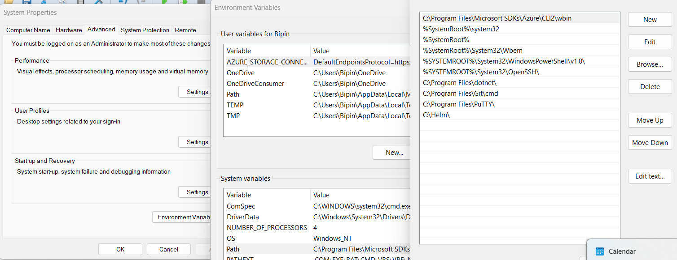

helm

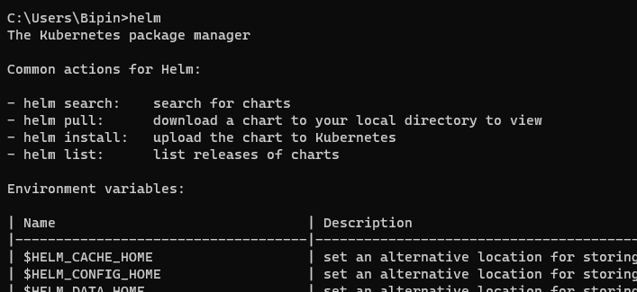

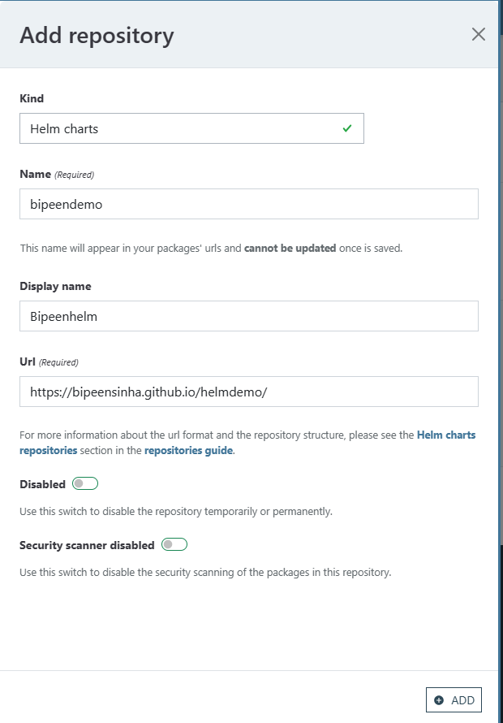

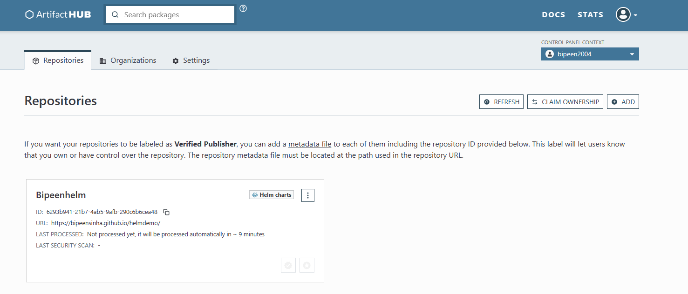

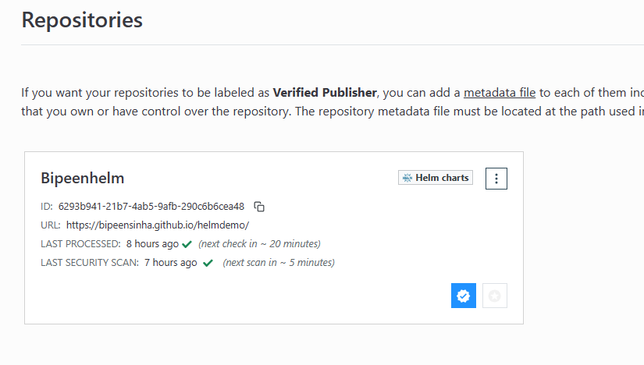

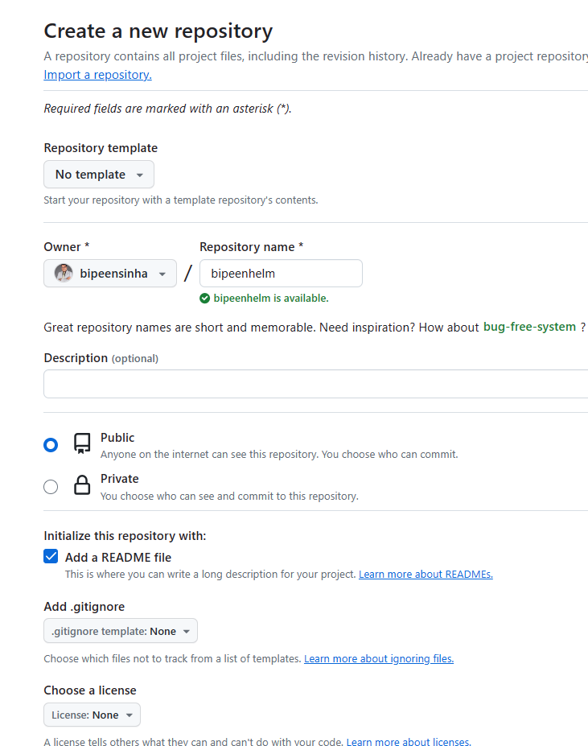

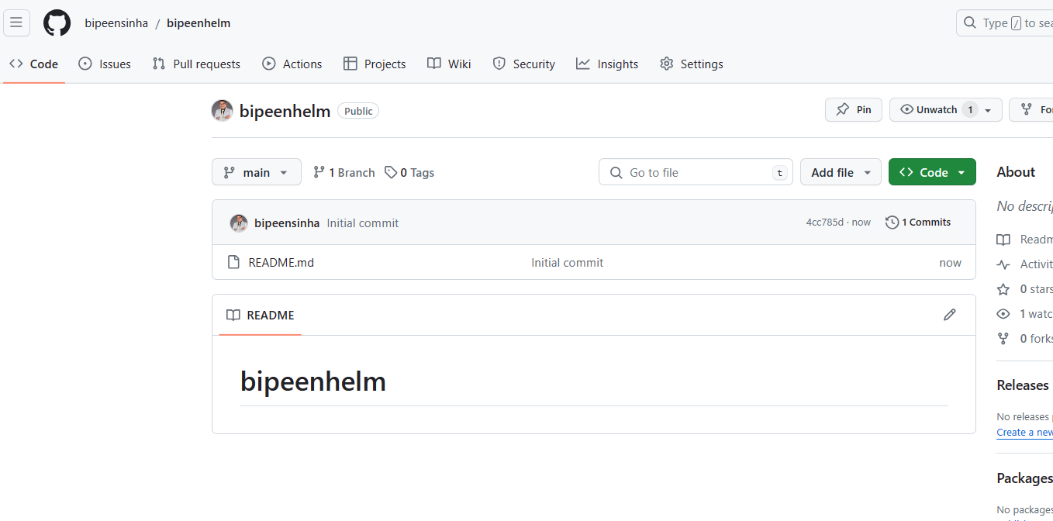

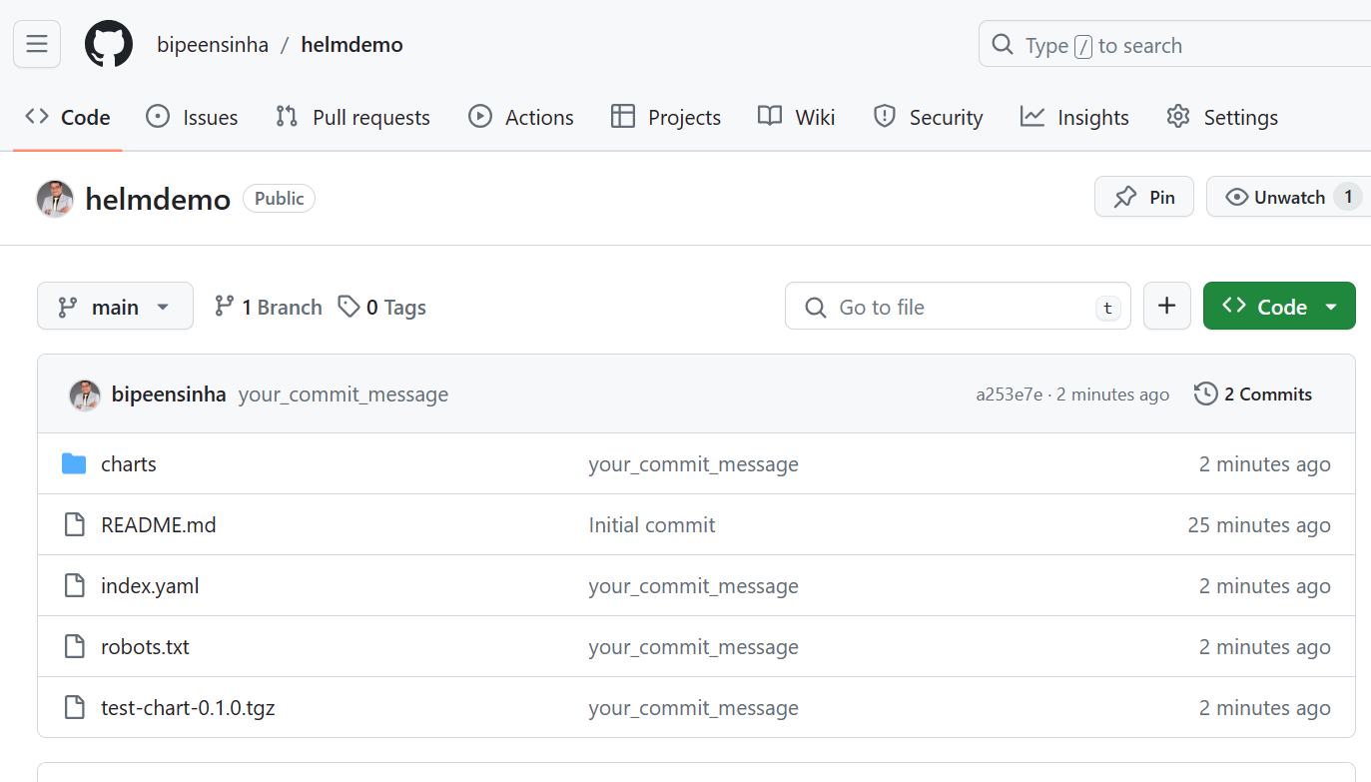

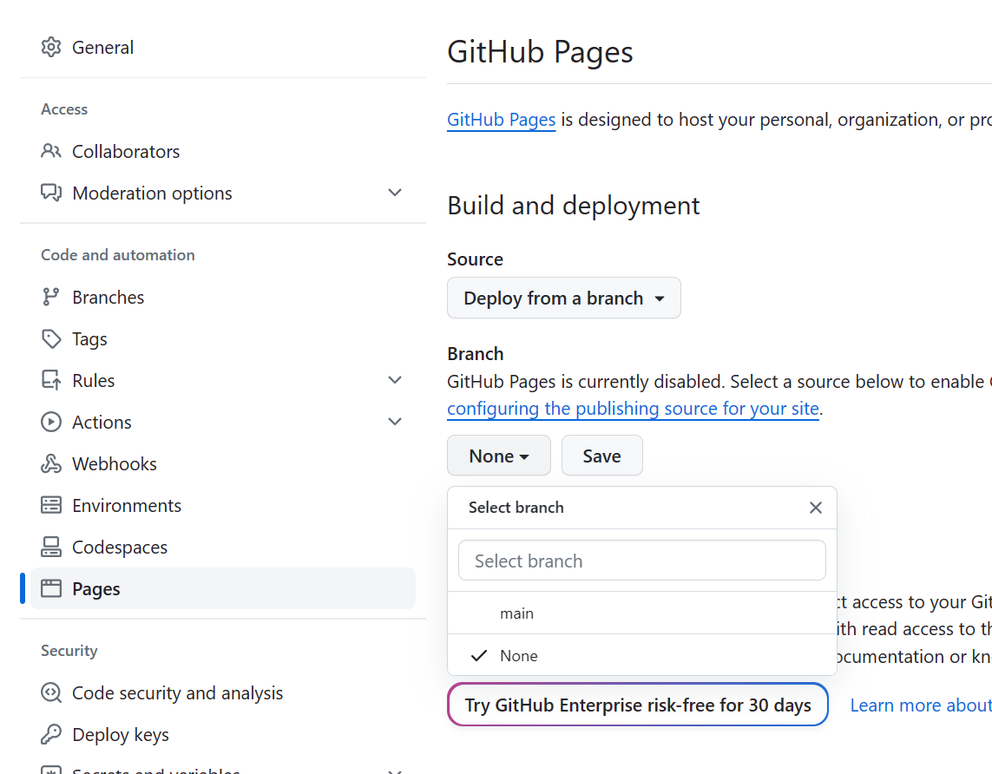



mkdir helmdemo-chart

cd helmdemo-chart

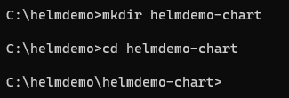

helm create bipeenhelm-chart



cd bipeenhelm-chart/templates

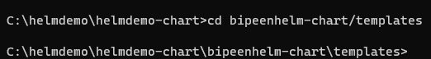

del /f *



rmdir /s tests

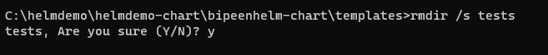

cd..

code .

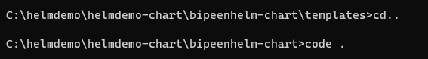

appVersion: "0.1.0 dev"

appVersion: "0.1.0 dev"

icon: https://www.google.com/images/branding/googlelogo/2x/googlelogo_color_272x92dp.png

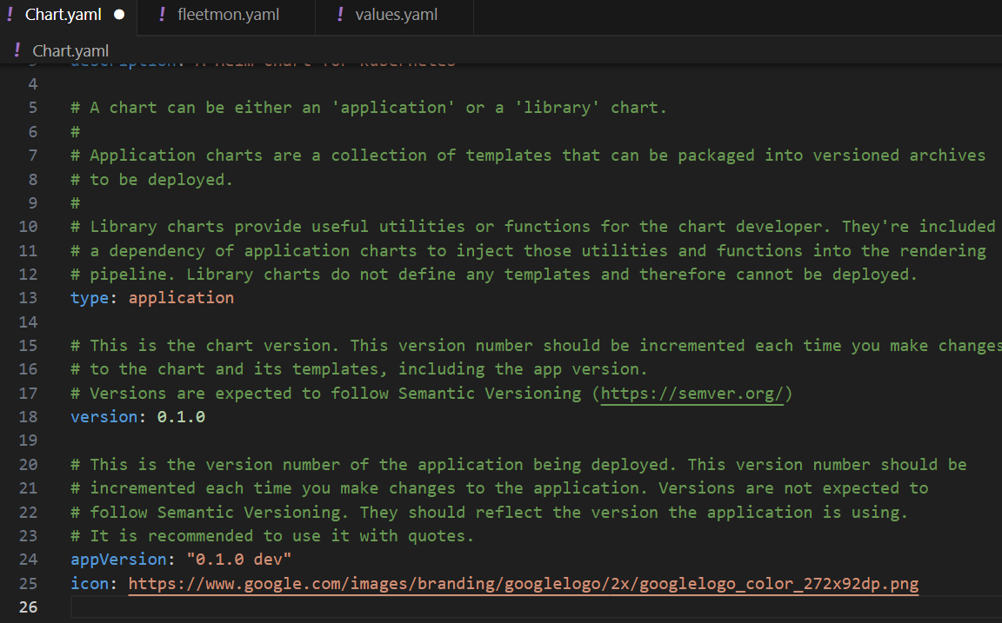

apiVersion: apps/v1

kind: Deployment

metadata:

  name: webapp

spec:

  selector:

    matchLabels:

      app: webapp

  replicas: 1

  template: # template for the pods

    metadata:

      labels:

        app: webapp

    spec:

      containers:

      - name: webapp

        # Note to deployer - add -dev at the end of here for development version

        image: {{ .Values.webapp.dockerrepo}}/k8s-fleetman-helm-demo:v1.0.0

---

apiVersion: v1

kind: Service

metadata:

  name: fleetman-webapp

spec:

  selector:

    app: webapp

  ports:

    - name: http

      port: 80

      nodePort: 30080

  type: NodePort

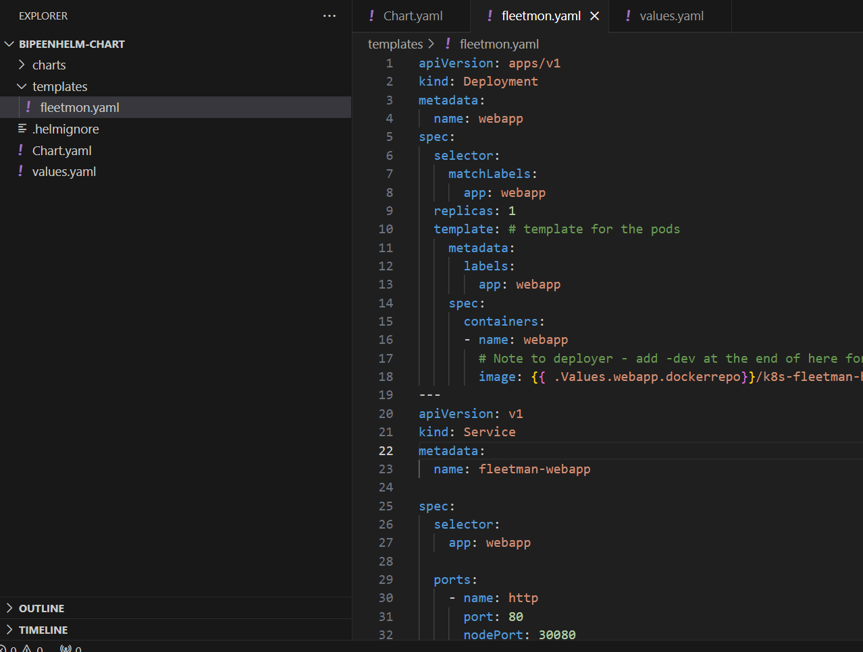

webapp:

  noofreplica: 4

dockerRepo: "richardchesterwood"

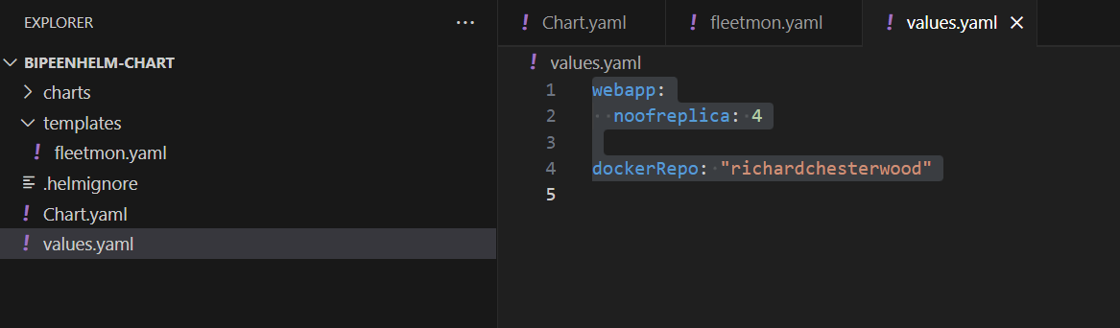

cd..

helm package bipeenhelm-chart



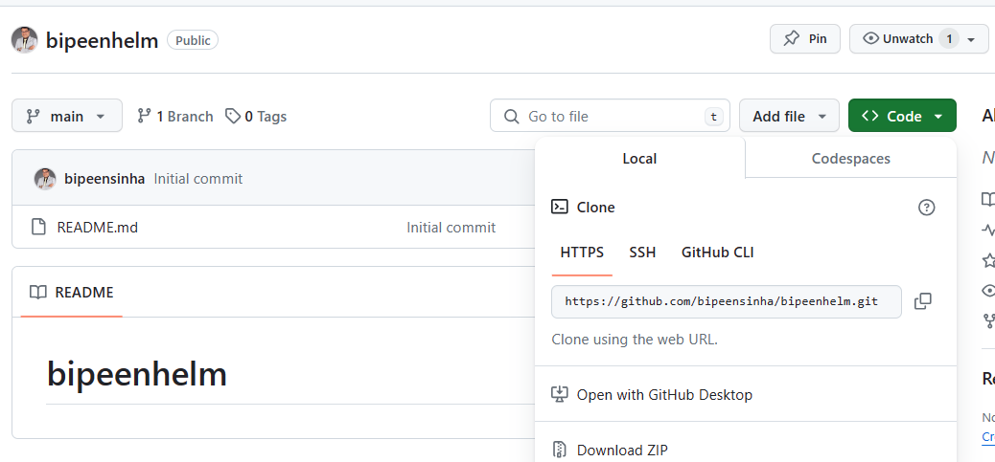

cd ..

git clone https://github.com/bipeensinha/bipeenhelm.git

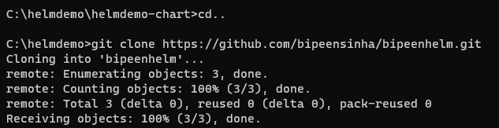

cd bipeenhelm

mkdir charts && cd charts

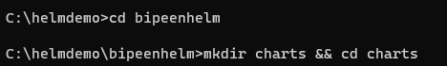

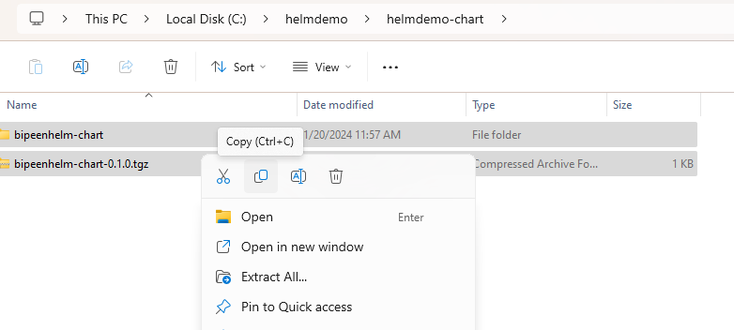

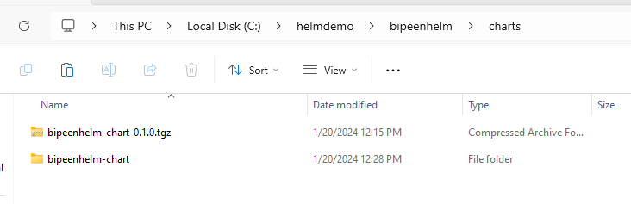

Dir

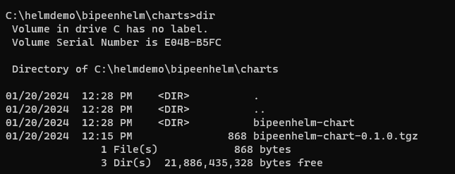

cd..



helm lint charts/bipeenhelm-chart

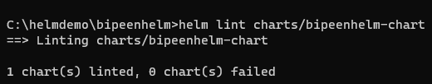

echo -e “User-Agent: *\nDisallow: /” > robots.txt



Helm package charts/bipeenhelm-chart/



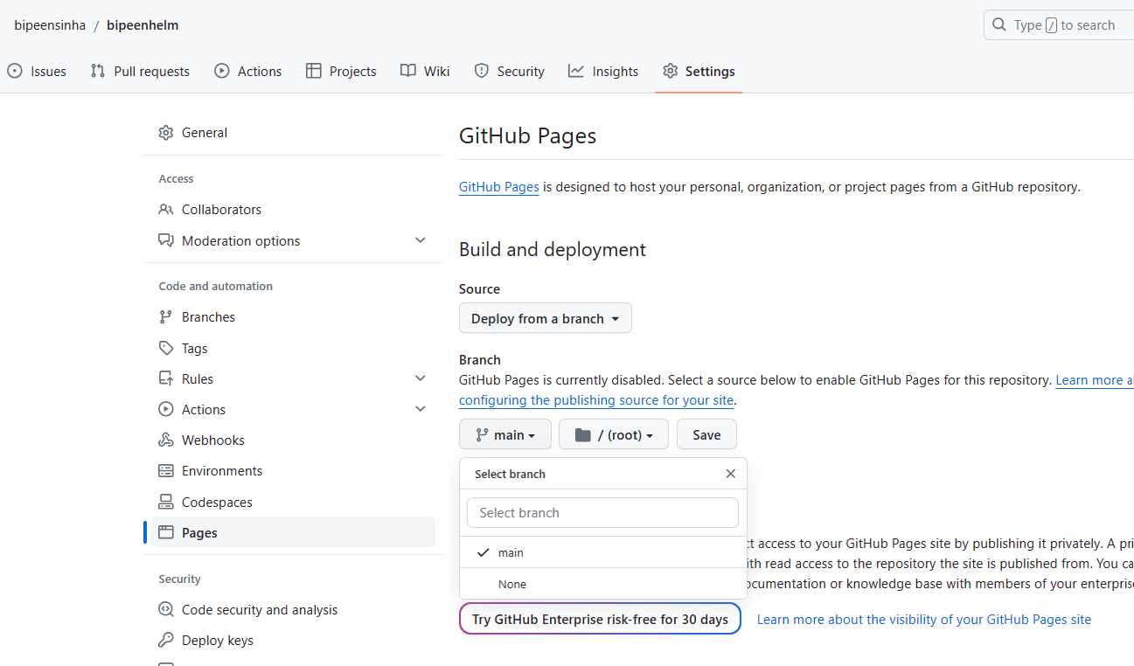

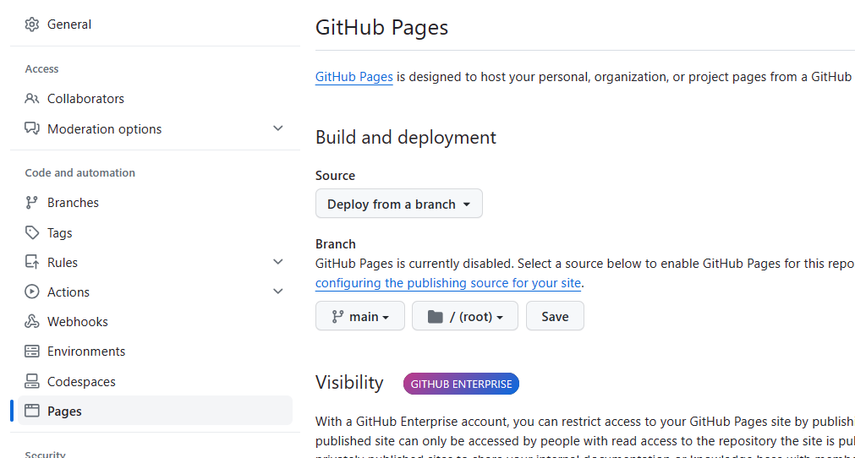

helm repo index --url bipeensinha.github.io/bipeenhelm .



Git add .

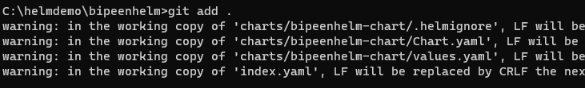

git commit -m "Bipeen Sinha First helm Chart"

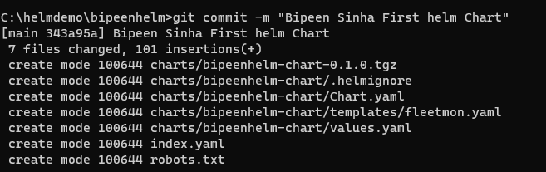

git push

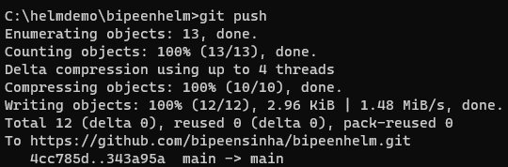

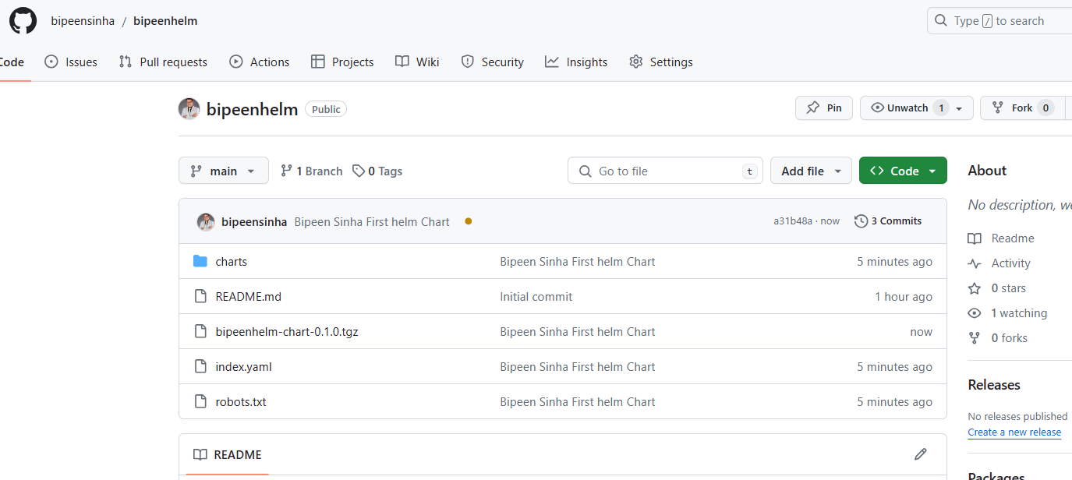

<https://artifacthub.io/>

click add

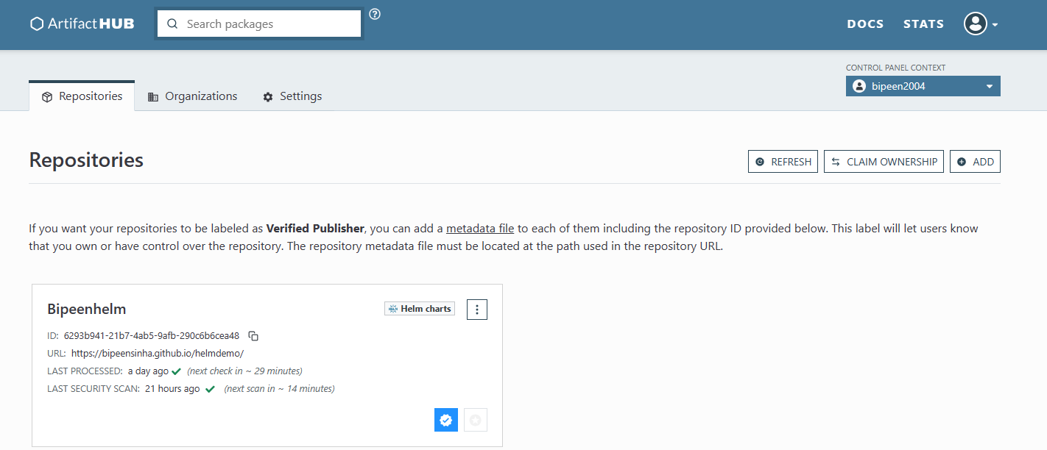

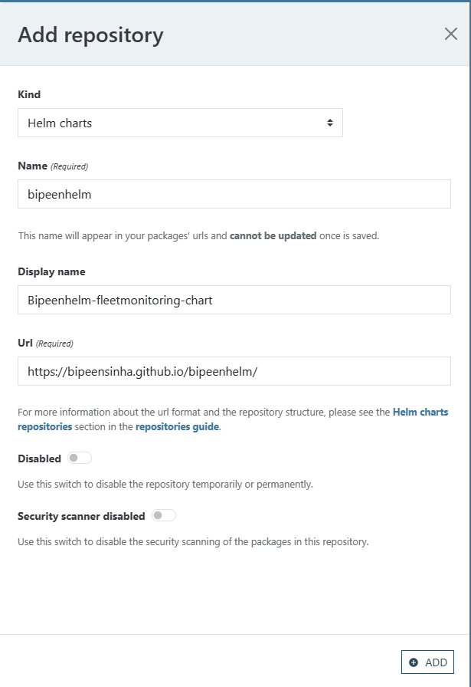

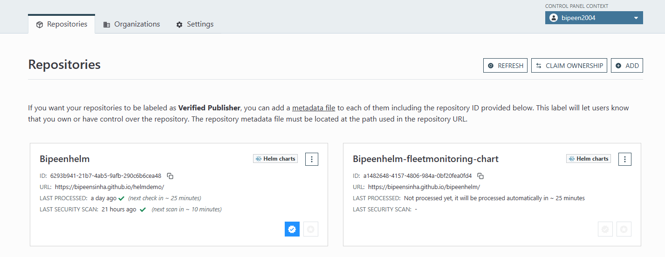

Ut will take 30 min to live

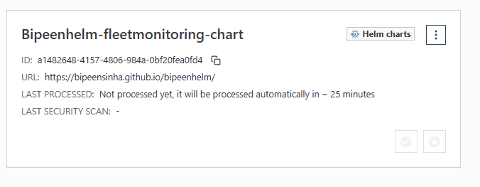

Create new file **artifacthub-repo.yml**

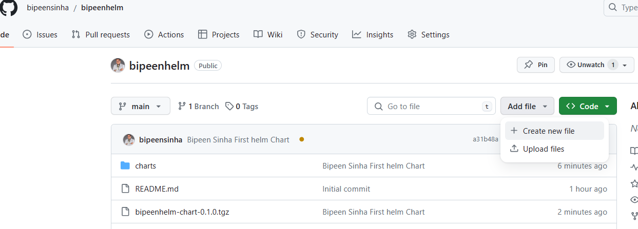

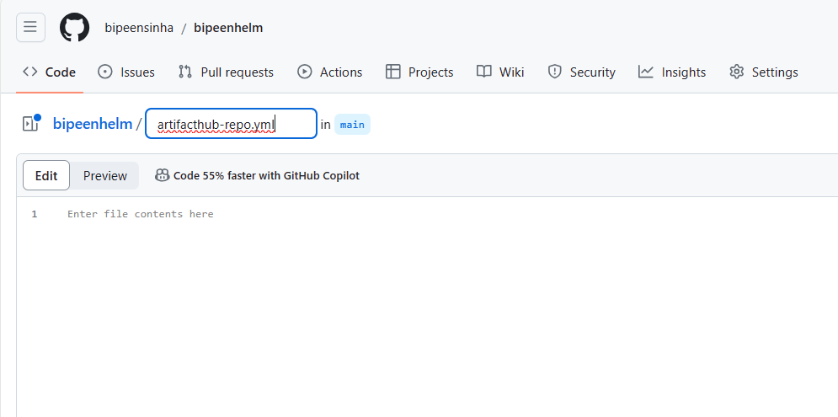

repositoryID: a1482648-4157-4806-984a-0bf20fea0fd4

owners:

- name: Bipeen Sinha

email: bipeen.sinha@hotmail.com

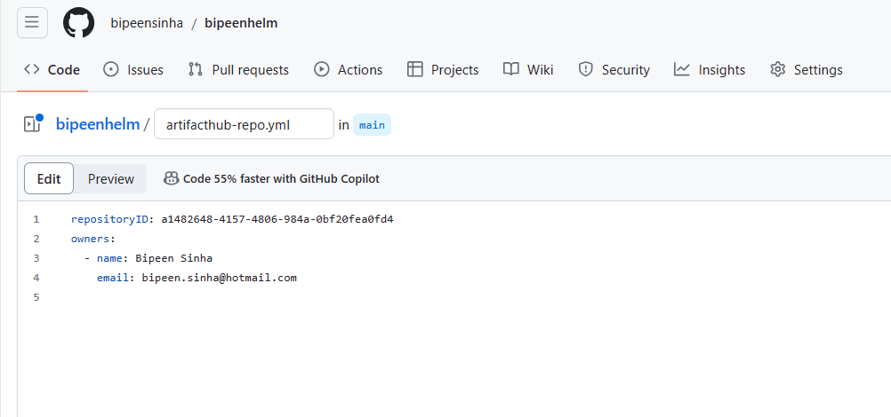

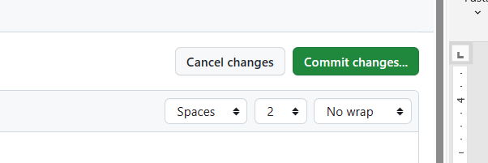

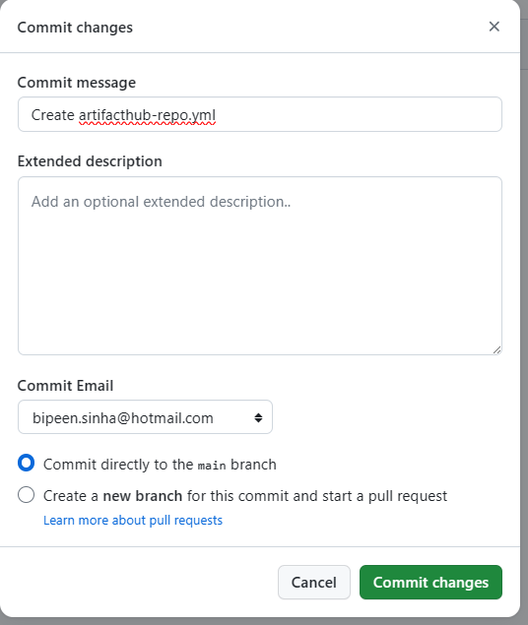

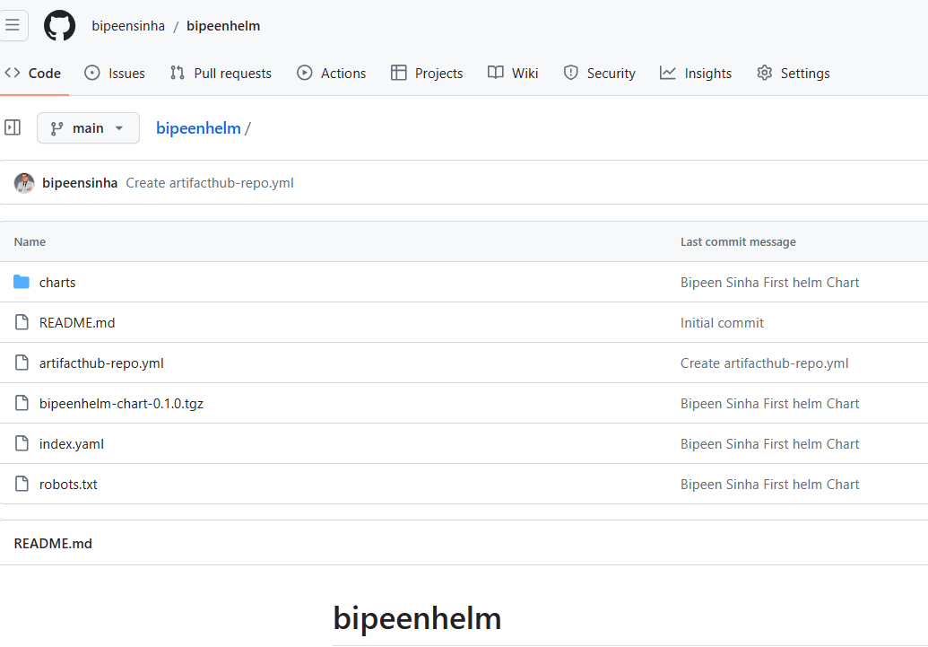

In 10-15 min you should see the pages in github is live

**Your site is live at**[**https://bipeensinha.github.io/bipeenhelm/**](https://bipeensinha.github.io/bipeenhelm/)

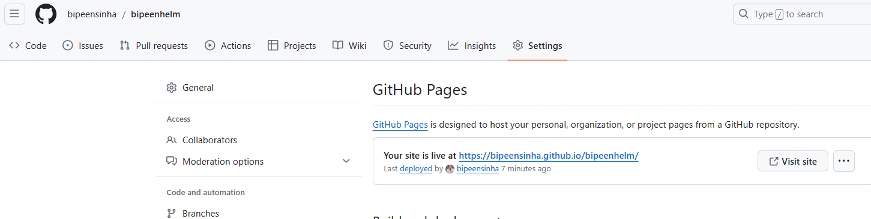

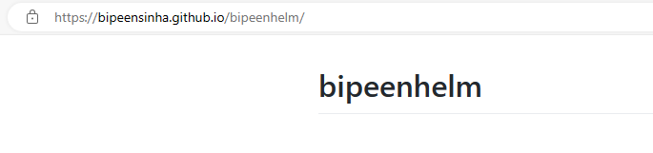

# Create Helm Chart From Scratch

C:\>cd helmdemo

C:\helmdemo>git clone https://github.com/bipeensinha/helmdemo.git

Cloning into 'helmdemo'...

remote: Enumerating objects: 3, done.

remote: Counting objects: 100% (3/3), done.

remote: Total 3 (delta 0), reused 0 (delta 0), pack-reused 0

Receiving objects: 100% (3/3), done.

C:\helmdemo>cd helmdemo

C:\helmdemo\helmdemo>mkdir charts && cd charts

C:\helmdemo\helmdemo\charts>dir

Volume in drive C has no label.

Volume Serial Number is E04B-B5FC

Directory of C:\helmdemo\helmdemo\charts

01/19/2024 12:29 PM <DIR> .

01/19/2024 12:29 PM <DIR> ..

01/19/2024 12:27 PM <DIR> test-chart

01/19/2024 12:00 PM 1,843 test-chart-0.1.0.tgz

1 File(s) 1,843 bytes

3 Dir(s) 22,519,054,336 bytes free

C:\helmdemo\helmdemo\charts>cd test-chart

C:\helmdemo\helmdemo\charts\test-chart>dir

Volume in drive C has no label.

Volume Serial Number is E04B-B5FC

Directory of C:\helmdemo\helmdemo\charts\test-chart

01/19/2024 12:27 PM <DIR> .

01/19/2024 12:29 PM <DIR> ..

01/19/2024 11:47 AM 349 .helmignore

01/19/2024 11:47 AM 1,146 Chart.yaml

01/19/2024 11:47 AM <DIR> charts

01/19/2024 12:27 PM <DIR> templates

01/19/2024 11:47 AM 2,363 values.yaml

3 File(s) 3,858 bytes

4 Dir(s) 22,519,054,336 bytes free

C:\helmdemo\helmdemo\charts\test-chart>helm lint charts/test-chart

==> Linting charts/test-chart

Error unable to check Chart.yaml file in chart: CreateFile charts\test-chart\Chart.yaml: The system cannot find the path specified.

Error: 1 chart(s) linted, 1 chart(s) failed

C:\helmdemo\helmdemo\charts\test-chart>code .

C:\helmdemo\helmdemo\charts\test-chart>cd..

C:\helmdemo\helmdemo\charts>cd..

C:\helmdemo\helmdemo>helm lint charts/test-chart

==> Linting charts/test-chart

[INFO] Chart.yaml: icon is recommended

1 chart(s) linted, 0 chart(s) failed

C:\helmdemo\helmdemo>helm lint charts/test-chart

==> Linting charts/test-chart

1 chart(s) linted, 0 chart(s) failed

C:\helmdemo\helmdemo>helm lint charts/test-chart/

==> Linting charts/test-chart/

1 chart(s) linted, 0 chart(s) failed

C:\helmdemo\helmdemo>echo -e “User-Agent: *\nDisallow: /” > robots.txt

C:\helmdemo\helmdemo>Helm package charts/test-chart/

Successfully packaged chart and saved it to: C:\helmdemo\helmdemo\test-chart-0.1.0.tgz

C:\helmdemo\helmdemo>ls

'ls' is not recognized as an internal or external command,

operable program or batch file.

C:\helmdemo\helmdemo>dir

Volume in drive C has no label.

Volume Serial Number is E04B-B5FC

Directory of C:\helmdemo\helmdemo

01/19/2024 12:40 PM <DIR> .

01/19/2024 12:27 PM <DIR> ..

01/19/2024 12:29 PM <DIR> charts

01/19/2024 12:27 PM 10 README.md

01/19/2024 12:39 PM 35 robots.txt

01/19/2024 12:40 PM 1,897 test-chart-0.1.0.tgz

3 File(s) 1,942 bytes

3 Dir(s) 22,533,672,960 bytes free

C:\helmdemo\helmdemo>Helm repo index --url https://github.com/bipeensinha/helmdemo .

C:\helmdemo\helmdemo>git add .

warning: in the working copy of 'charts/test-chart/.helmignore', LF will be replaced by CRLF the next time Git touches it

warning: in the working copy of 'charts/test-chart/Chart.yaml', LF will be replaced by CRLF the next time Git touches it

warning: in the working copy of 'charts/test-chart/values.yaml', LF will be replaced by CRLF the next time Git touches it

warning: in the working copy of 'index.yaml', LF will be replaced by CRLF the next time Git touches it

C:\helmdemo\helmdemo>git commit -m "your_commit_message"

[main a253e7e] your_commit_message

8 files changed, 215 insertions(+)

create mode 100644 charts/test-chart-0.1.0.tgz

create mode 100644 charts/test-chart/.helmignore

create mode 100644 charts/test-chart/Chart.yaml

create mode 100644 charts/test-chart/templates/Feelt-monitoring-demo.yaml

create mode 100644 charts/test-chart/values.yaml

create mode 100644 index.yaml

create mode 100644 robots.txt

create mode 100644 test-chart-0.1.0.tgz

C:\helmdemo\helmdemo>git push --all

git: 'push --all' is not a git command. See 'git --help'.

C:\helmdemo\helmdemo>git push

Enumerating objects: 14, done.

Counting objects: 100% (14/14), done.

Delta compression using up to 4 threads

Compressing objects: 100% (12/12), done.

Writing objects: 100% (13/13), 6.91 KiB | 2.30 MiB/s, done.

Total 13 (delta 0), reused 0 (delta 0), pack-reused 0

To https://github.com/bipeensinha/helmdemo.git

fd1ab3b..a253e7e main -> main

C:\helmdemo\helmdemo>helm registry login -u bipeensinha myrepo

Password:

time="2024-01-19T13:16:52+05:30" level=info msg="Error logging in to endpoint, trying next endpoint" error="Get \"https://myrepo/v2/\": dial tcp: lookup myrepo: no such host"

Error: Get "https://myrepo/v2/": dial tcp: lookup myrepo: no such host

C:\helmdemo\helmdemo>helm registry login -u bipeen2004 bipeenhelm

Password:

time="2024-01-19T13:18:15+05:30" level=info msg="Error logging in to endpoint, trying next endpoint" error="Get \"https://bipeenhelm/v2/\": dial tcp: lookup bipeenhelm: no such host"

Error: Get "https://bipeenhelm/v2/": dial tcp: lookup bipeenhelm: no such host

C:\helmdemo\helmdemo>Helm repo index --url https://bipeensinha.github.io/helmdemo/ .

C:\helmdemo\helmdemo>git commit -m "your_commit_message"

On branch main

Your branch is up to date with 'origin/main'.

Changes not staged for commit:

(use "git add <file>..." to update what will be committed)

(use "git restore <file>..." to discard changes in working directory)

modified: index.yaml

no changes added to commit (use "git add" and/or "git commit -a")

C:\helmdemo\helmdemo>git add .

warning: in the working copy of 'index.yaml', LF will be replaced by CRLF the next time Git touches it

C:\helmdemo\helmdemo>git commit -m "your_commit_message"

[main 8489c6c] your_commit_message

1 file changed, 5 insertions(+), 5 deletions(-)

C:\helmdemo\helmdemo>git push

To https://github.com/bipeensinha/helmdemo.git

! [rejected] main -> main (fetch first)

error: failed to push some refs to 'https://github.com/bipeensinha/helmdemo.git'

hint: Updates were rejected because the remote contains work that you do

hint: not have locally. This is usually caused by another repository pushing

hint: to the same ref. You may want to first integrate the remote changes

hint: (e.g., 'git pull ...') before pushing again.

hint: See the 'Note about fast-forwards' in 'git push --help' for details.

C:\helmdemo\helmdemo>git pull https://github.com/bipeensinha/helmdemo.git

remote: Enumerating objects: 4, done.

remote: Counting objects: 100% (4/4), done.

remote: Compressing objects: 100% (3/3), done.

remote: Total 3 (delta 1), reused 0 (delta 0), pack-reused 0

Unpacking objects: 100% (3/3), 1.02 KiB | 65.00 KiB/s, done.

From https://github.com/bipeensinha/helmdemo

* branch HEAD -> FETCH_HEAD

Merge made by the 'ort' strategy.

artifacthub-repo.yml | 4 ++++

1 file changed, 4 insertions(+)

create mode 100644 artifacthub-repo.yml

C:\helmdemo\helmdemo>git add .

C:\helmdemo\helmdemo>git commit -m "your_commit_message"

On branch main

Your branch is ahead of 'origin/main' by 3 commits.

(use "git push" to publish your local commits)

nothing to commit, working tree clean

C:\helmdemo\helmdemo>git push

Enumerating objects: 9, done.

Counting objects: 100% (8/8), done.

Delta compression using up to 4 threads

Compressing objects: 100% (5/5), done.

Writing objects: 100% (5/5), 638 bytes | 638.00 KiB/s, done.

Total 5 (delta 3), reused 0 (delta 0), pack-reused 0

remote: Resolving deltas: 100% (3/3), completed with 2 local objects.

To https://github.com/bipeensinha/helmdemo.git

b35aee5..830414b main -> main

C:\helmdemo\helmdemo>Helm repo index --url https://bipeensinha.github.io/helmdemo/ .

